
All Vermigrow Products are organically approved

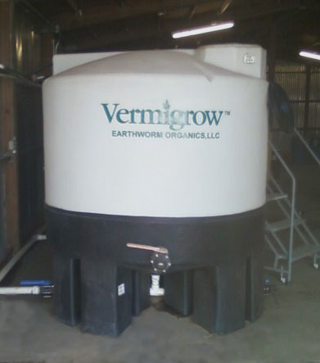

This is one of seven 1000 gallon tanks that we use in our brewing process.

The fresh liquid tea is just added into the irrigation water at the required application rate.

Economical to use and it works great!
Earthworm Compost Tea
No matter what you are growing, or the type of soil you are growing in, your plants need strong roots to get the job done and optimize yields. Earthworms have been tasked with this important job for millions of years.
Building upon what our little friends do so well we are now able to help create, stimulate and grow out the root zones by adding balanced micronutrients and other beneficials to the already potent recipe.
In addition, we work with our grower to create custom blends to optimize results and we work our brew and delivery schedules to mesh with yours insuring the absolute freshest brew.
And while there are some times the ground needs the bulk of composted, organic material most of the time your plants will respond using “tea” even if the organics level of your soil is depleted.
This becomes important when looking at both ease of application and cost savings benefits.
Now let’s look at some of the other major benefits of using earthworm based organic amendments…

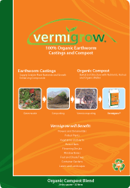


*Vermigrow Products are available in the original worm casting compost and also in a custom blended liquid “tea” with micronutrients added.

*All our products are factory direct and available in both packaged and in “bulk”. Perfect for the small home garden or largest commercial application and most everything in between!
VERMIGROW™ ORGANICS

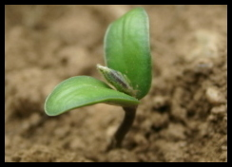

Earthworm Organics, LLC
PO Box 685
La Quinta, CA 92247

Office: 760.863.1950
Fax: 888.841.8079

Gary Nichols-Sales
760.689.2126 Direct
gn@VermigrowProducts.com
www.VermigrowProducts.com

All Vermigrow Products
are organically certified by Organic Certifiers and manufactured to the highest standards by Earthworm
Organics, LLC

WHY USE COMPOST TEAS?

Some of the benefits of using fortified Vermigrow earthworm compost tea include:

- Increased disease suppression

- Provides nutrients for plants and food resources
for microbes

- Inoculating microorganisms into the soil or on to
leaf surfaces increases cycling nutrients into plant

- Increases the nutritional quality of plant produce

- Reduces the negative impacts of chemical based pesticides, herbicides and fertilizers on beneficial microbes in the root system

- Improves plant growth and increases root mass

- Makes fertilizer more effective by increasing plant uptake of nutrients

- Improves the plants ability to withstand stress

- Custom “brews” address specific plant needs

Continue flyer text here. Continue flyer text here. Continue flyer text here. Continue flyer text here. Continue flyer text here. Continue flyer text here. Continue flyer text here. Continue flyer text here.
Continue flyer text here. Continue flyer text here. Continue flyer text here. Continue flyer text here. Continue flyer text here. Continue flyer text here. Continue flyer text here. Continue flyer text here. Continue flyer text here. Continue flyer text here.

